Michael Osei

2/24/23

COSC 480

Week3 Git Lab

Commands:

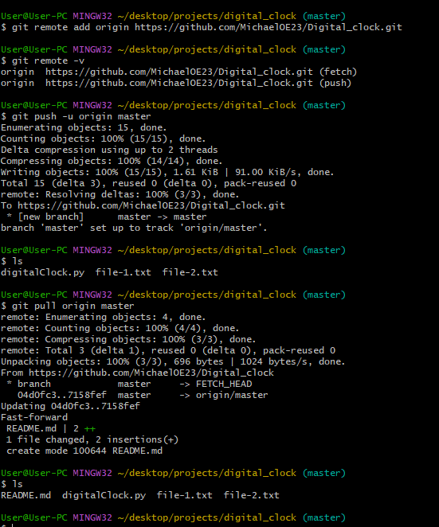

GitHub:

